Building Block Of Salesforce Assignment

General Guidelines:
- Object name, field names, tab names, email templates and error messages should be presentable. Run spell check wherever necessary.
- In case if you delete an object or a field, then please ensure that you delete it permanently from the org. If you do not, then, you will not be able to complete the assignment.

Create the below Given Objects & required fields in your respective SF Org(Developer Org). This org will be used throughout the training period.

Questions:
- Create Employee data in Salesforce as below. Create a custom list view where you can see these details.

Name | Email | UserName | Manager | Is Manager
John Smith | < use your email for assignment> | Jhon.<yourname>@bfl.training.com | Null | TRUE
Paul Kevin | < use your email for assignment> | Paul.<yourname>@bfl.training.com | John Smith | FALSE

Hint :
- Use SF standard user object
- Select User license as Salesforce
- Select profile as Standard User
- Use custom fields for last two columns

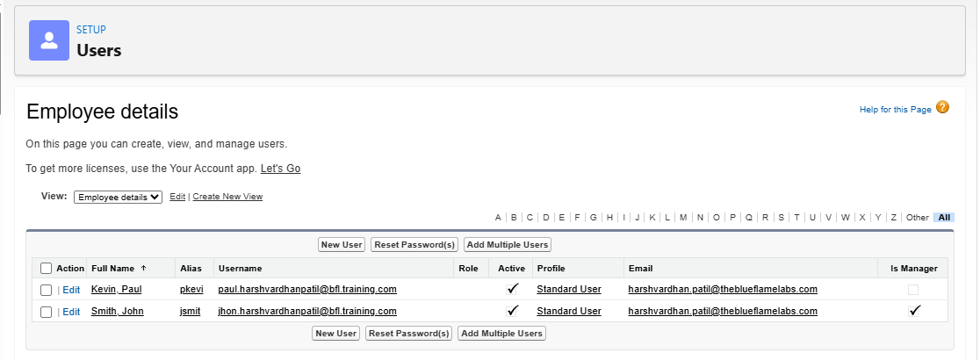
- Project (Custom Object)

Fields:
Project Name : Text
Project Manager: Lookup user
Client : Custom lookup (Account object)
Allocated Hours : Number
Estimated Hours : Rollup of all the estimated hours on each task related to project (Number Type)
Billable Hours : Rollup of all the billable hours on each task related to project (Number Type)

Non-Billable Hours : Rollup of all the non-billable hours on each task related to project (Number Type)

Billing Per Hour : Currency
Total Billing : Formula (Billing per hour * Billable Hours)
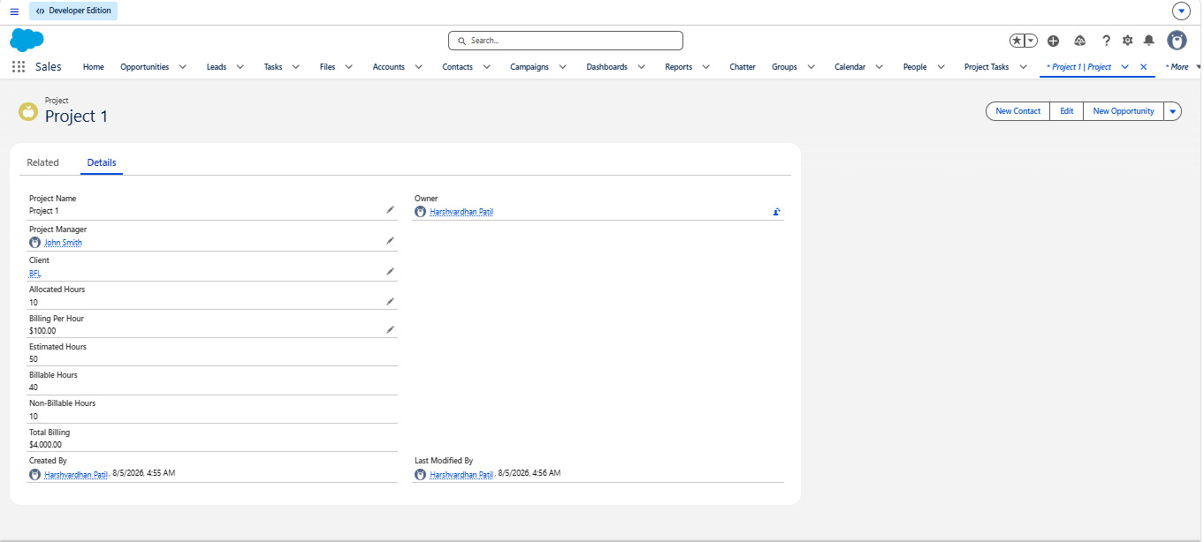

- Project Member (Custom Junction Object)
Fields:
Project : custom master-detail (Project)
Member : Lookup (User)
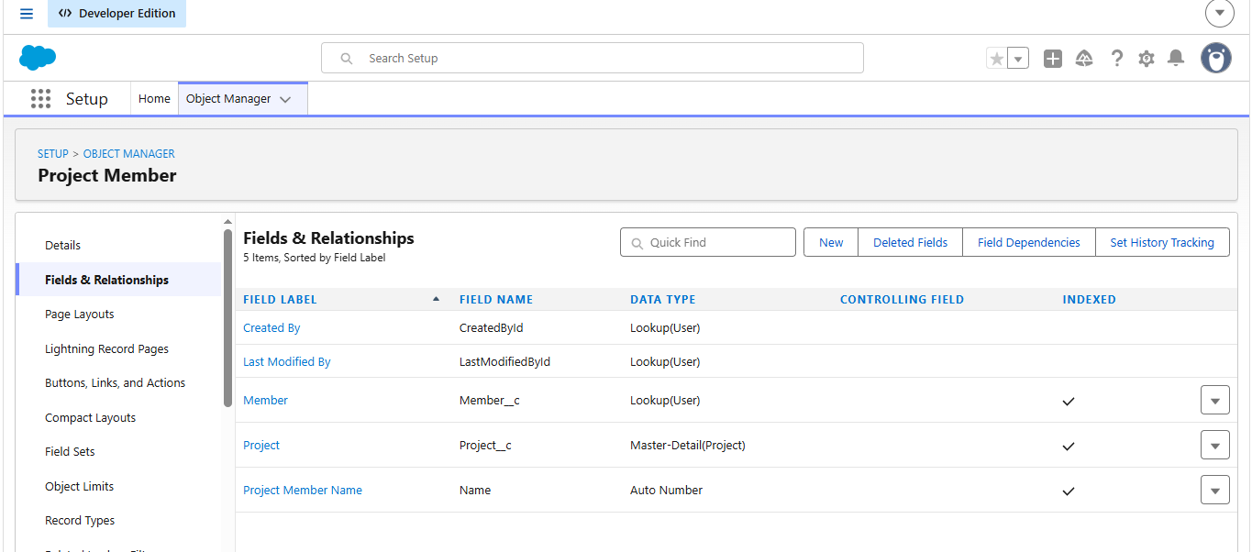s

- Case(Standard Case Object - Rename Case to Project Task)
Fields:
Project : Lookup (Project)
Estimated Hours :
Billable Hours :
Non-Billable Hours :
Subject : (Standard Subject field)Task Subject
Assigned To: (Standard Owner Field)
User Story : (Standard Description Field)
Acceptance Criteria : Rich Text Area (Custom Field)
Status (Picklist - New, In Progress, QA, Completed)
Assigned Date : DateTime
Due Date : DateTime
Completed Date : DateTime
Report To (Lookup to User)
Type : (Picklist - Story/Bug)

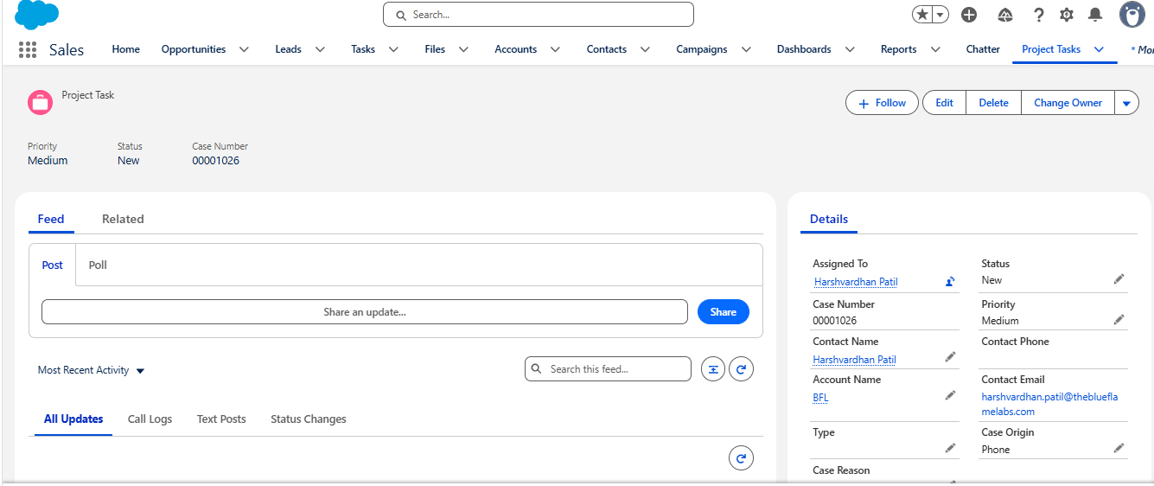
- Task Comments (Standard Case Comment)
Create an Account with the name as ‘BFL’. Now create a Project Task record. Create a Task Comments record associated with this case record. The comment should be ‘This is a case comment’
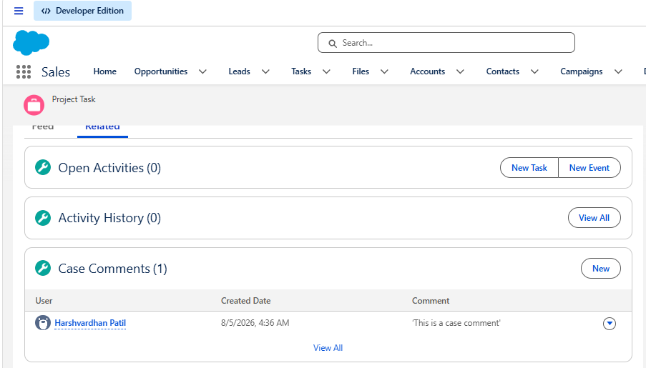

- Weekly Snapshot (Custom Object)

Fields:
Week Start Date : Date
Week End Date : Date
Estimated Hours : number
Billable Hours: number
Non-Billable Hours : number
Summary : RichTextArea
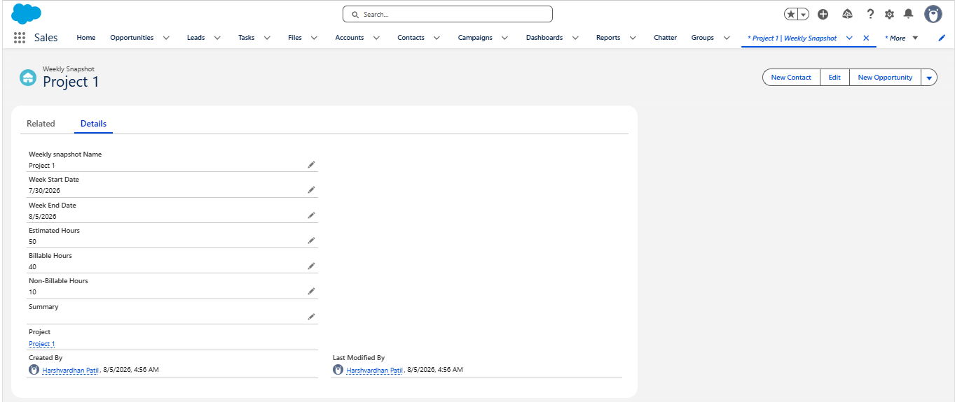
- Is there any data loss when converting the fields from one data type to another ? Explain.
Yes, data loss can occur during field type conversion in Salesforce. Salesforce allows administrators to change data types, but if the target data type is incompatible with the existing data structure, the system may truncate, corrupt, or completely delete the data within that field across all records.

- What happens when a field is deleted ? What happens when you restore it ?
When a custom field is deleted in Salesforce, it enters a 15-day soft-delete state where its data is hidden but remains in the database, still counting toward object limits. Salesforce automatically strips it from layouts and reports, but will block the deletion if the field is actively referenced in Apex code, validation rules, or flows. If the 15-day grace period expires, the field and its data are permanently hard-deleted. Restoring the field recovers the data, but places the field in a quarantined, non-functional state. Salesforce appends a _del suffix to the API name, removes it from layouts, strips "Required" or "Unique" constraints, and downgrades Master-Detail relationships to standard Lookups. To make it operational again, an administrator must manually fix the API name, re-add it to layouts, and re-enable its original settings.

- How many custom detail levels can you have in a master detail relationship ?
In a Salesforce master-detail relationship, you can have a maximum of three custom detail levels. This is commonly referred to as a three-level parent-child-grandchild relationship hierarchy.

- Complete Data Modelling trailhead module.
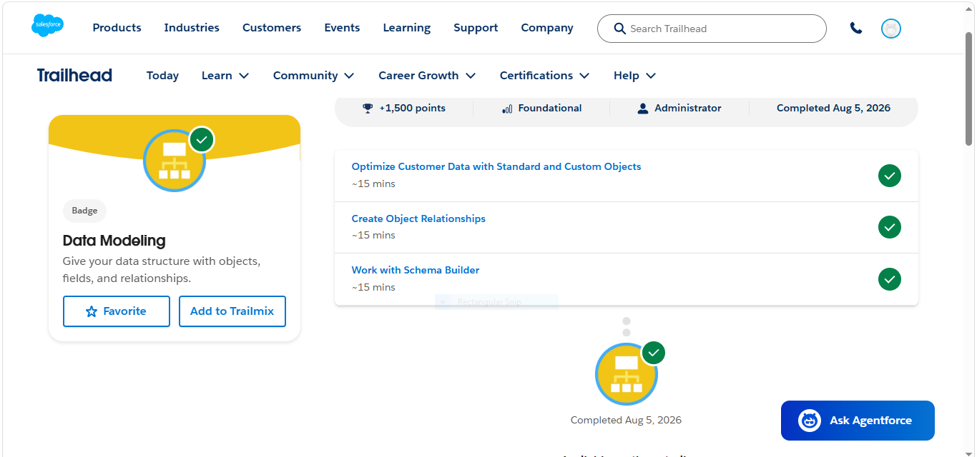

Extra Questions
- For custom field in Auto number, if the display number is 0000 then what happens after 9999?
When a Salesforce auto-number field with the display format {0000} reaches 9999, the sequence automatically expands by adding a fifth digit, meaning the very next record created will be assigned 10000

- Different types of formula functions in advance formula:
Here are the four main types of formula functions in Salesforce advanced formulas:
Logical: Evaluates conditions (e.g., IF, AND, OR, CASE).
Text: Manipulates and checks string data (e.g., TEXT, ISPICKVAL, CONTAINS, BEGINS).
Math: Calculates and rounds numbers (e.g., ROUND, ABS, MAX, MOD).
Date & Time: Manages calendar dates and timestamps (e.g., TODAY, NOW, DATE, MONTH)

- In Many-to-many relationship what will happen if we delete the child record.
In a Salesforce many-to-many relationship, deleting a child record (the junction object record) simply removes the link between the two master records and moves that junction record to the Recycle Bin. Both master/parent records remain completely untouched and unaffected. Any roll-up summary fields on the parent records will automatically recalculate to reflect the deletion.

4.Which fields allow field history tracking (on both older and newer version)?
A] Field history tracking supports most standard and custom fields such as:
TEXT, NUMBER, CURRENCY, DATE, DATE/TIME, CHECKBOX, PICKLIST, LOOKUP, EMAIL, PHONE, URL

5. Which fields do not allow field history tracking on Field Audit Trail.
A] The following fields cannot be tracked :
FORMULA, ROLL-UP SUMMARY, AUTO NUMBER, LONG TEXT AREA, RICH TEXT AREA, MULTISELECT PICKLIST, SYSTEM FIELDS(LAST MODIFIED DATE, CREATED DATE)

6.Where is Schema Builder located?
A] Setup --> Quick find --> Schema Builder

7. How to create required fields?
Setup -> Object Manager -> Fields & Relationships -> New -> Field Type -> Check the Required checkbox -> Save

